This is the design documentation for my project. From my understanding, the important part of this project is to present a proof of concept to a potential stakeholder.

My first assumption was to look at the data that was provided. I looked at the Excel file that was provided and noticed the column names “Hotel Name, City, Continent, Country, Category, Star Rating, Temp Rating, Location, Price Per Night”. I would use these to filter out the data.

After looking at this, I created a user model to describe the user experience.

To summarise, the application asks the user what content they would like to visit, then asks the category, then the location, and finally the temperature rating. This information is then passed to a database and then the is returned to the user in a results page, which displays all of the holidays.

I have chosen to use the following four filters because I believe that gives the user more options to look through on the results page.

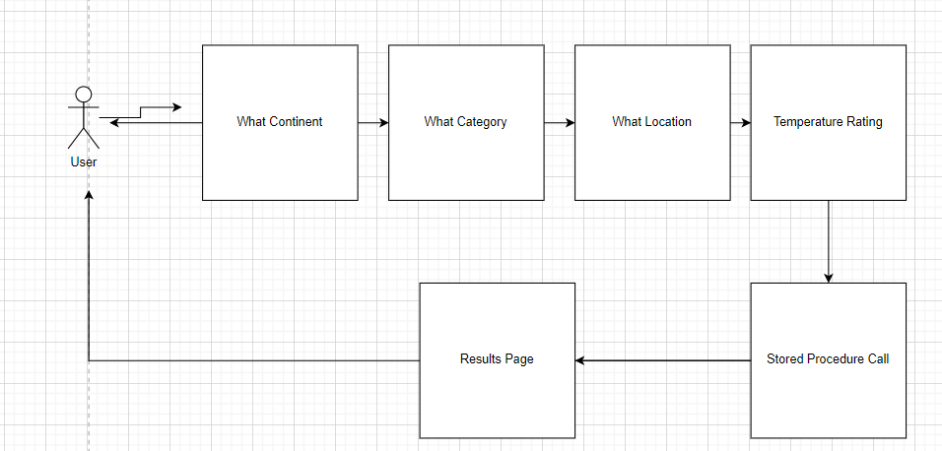

This is what my data model will look like. I will create a table called Holidays with the columns matching the data. I’ll make a stored procedure that accepts the parameters that the user will provide. At the moment, it is very simple, but I believe it could be added too fairly easily.

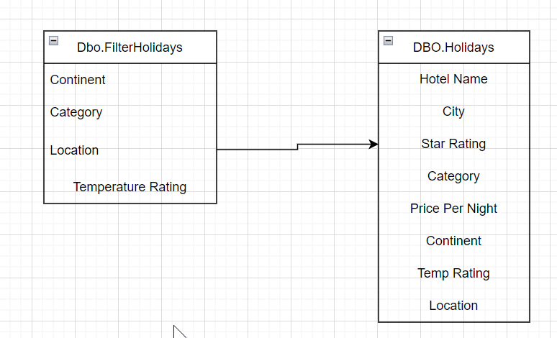

I will create an MVC and each page will save the input data in a session and pass it through to a stored procedure then finally results to the user.

I want the layout to look like below.

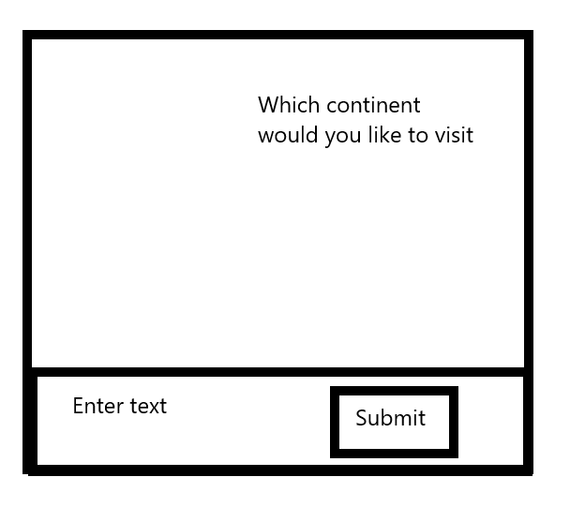

If an invalid input has been entered I would like an ‘Invalid Input’ message to appear. Prompting the user to try again.

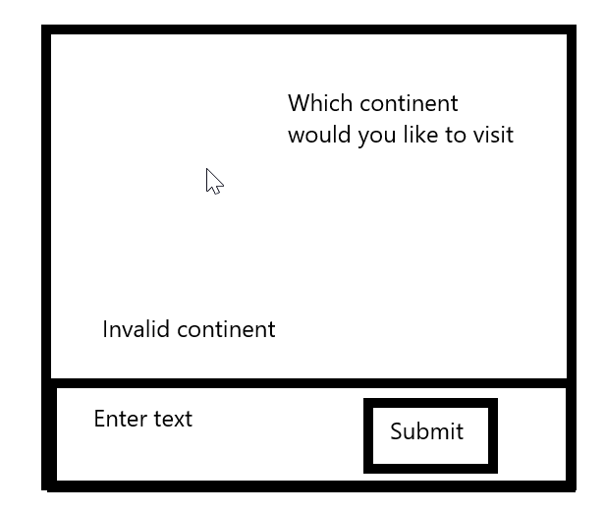

When the user navigates to the next page, I would like the previous answer visible on the screen.

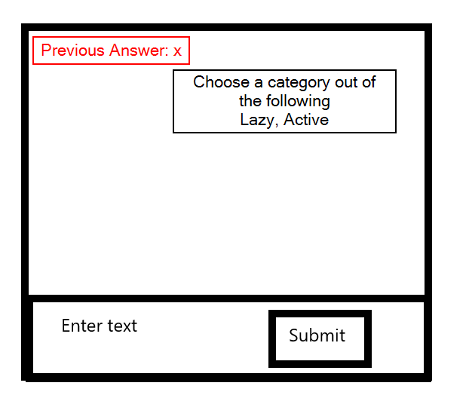

When the last question is answered, I want the results to show a screen like the following:

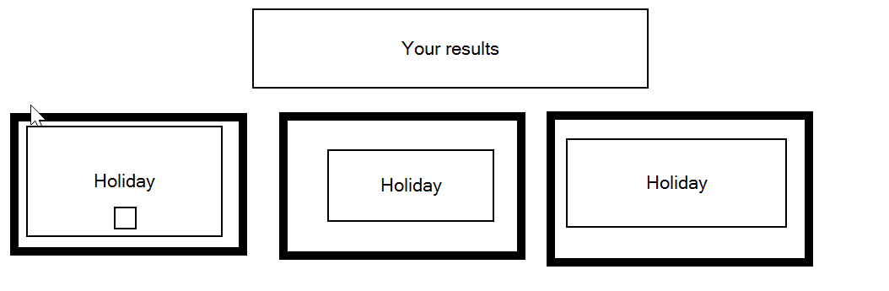

If I can design the app around this, I believe it will meet the criteria.